A few good books – Grades 1 and 2

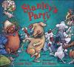
Bailey: Stanley’s Party c2003 dogs, humor
When a dog’s owners leave for the evening, he gets into a lot of mischief.
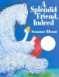
Bloom: A Splendid Friend Indeed c2005 friendship
A polar bear and a goose learn to get along and be friends.
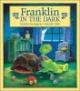
Bourgeois: Franklin in the Dark c1986 fear, fiction
A turtle afraid of small dark places, and therefore of crawling into his shell, asks a variety of animals for advice, only to find out that each has a fear of its own.
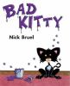
Bruel: Bad Kitty c2005 alphabet
Finding that there is no food in the house, a kitty chooses to be very bad.
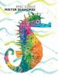
Carle: Mister Seahorse c2004 animals, fiction
Mrs. Seahorse lays her eggs, after which Mr. Seahorse carries the eggs through the sea, greeting other fish fathers.
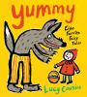
Cousins: Yummy: Eight Favorite Fairy Tales c2009 fairy tales
Simple text and bold illustrations tell eight classic fairy tales.
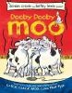
Cronin: Dooby, Dooby, Moo c2004 animal humor
Duck organizes the farm animals for a talent show at the county fair. The first prize is a trampoline.
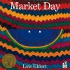
Ehlert: Market Day: A Story Told with Folk Art c2000 stories in rhyme, fiction
While keeping a diary, the young fly records how hard it is to be an insect.
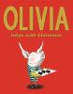
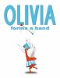
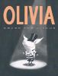
Falconer: Olivia series pigs, fiction
Olivia is a feisty pig who has too much energy for her own good.
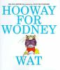
Lester: Hooway for Wodney Wat c1999 fantasy, abilities awareness
Students in Rodney’s class make fun of him, because he can’t pronounce his name properly; but it is his speech problem that helps to punish the class bully.
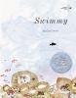
Lionni: Swimmy c1991 fish stories
A small black fish, finds a way to protect a school of small red fish from their natural enemies.
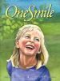
McKinley: One Smile c2002 kindness
While walking through the park with her mother, a child smiles at a discouraged stranger and sets off a chain of events that spreads kindness and comes full circle.
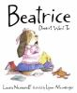
Numeroff: Beatrice Doesn't Want To c2004 realistic fiction, humor
Beatrice Doesn't Like to Read, but a librarian changes her attitude during a story session in this humorous, well illustrated book.
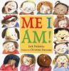
Prelutsky: Me I Am c2007 poetry
A book of poem for children celebrating being an individual.
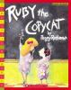
Rathmann: Ruby the Copycat c1991 school, fiction
Ruby wants to fit in on her first day at school, so she begins to copy her classmate Angela; but then Ruby's teacher shows her how much fun it is to just be herself.

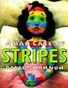
Shannon: A Bad Case of Stripes c1998 individuality, fiction
A girl who is always concerned about what others think of her wakes up one day to discover she is covered with stripes.
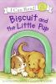
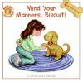
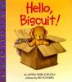
Capucilli: Biscuit series dog stories
Biscuit, the adorable little tan puppy, has many adventures.
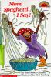
Gelman: More Spaghetti I Say c1993 stories in rhyme, humor
Minnie the monkey is too busy eating spaghett all day, in all ways to play with her friend Freddie.
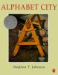
Johnson: Alphabet City c1995 alphabet
Photographs of objects in an urban setting present the letters of the alphabet.

