A few good books – Grades 4 and 5

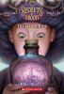
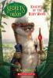
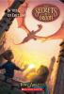
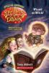
Abbot: Secrets of Droon series fantasy
Take along with a trio of best friends who stumble upon the magical world of Droon.
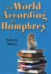
Birney: The World According to Humphrey c2005 fiction, humor
Humphrey, a classroom hamster, surveys his surroundings and finds ways to help the children in the class.
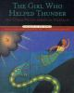
Bruchac: The Girl Who Helped Thunder and Other Native American Folktales c2008 folklore
A collection of illustrated Native American folktales.
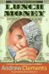
Clements: Lunch Money c1994 school, humor
Hart is a popular boy who sometimes "goofs off". When he hits the music teacher with a rubber band, he is put in charge of the holiday concert. Both Hart and his teacher learn lessons.
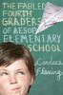
Fleming: The Fabled Fourth Graders of Aesop Elementary School c2007 fiction, school
Mr. Jupiter becomes the 4th grade teacher of an unruly class with surprising results.
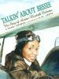
Grimes: Talkin' About Bessie c2002 biography, ethnic diversity
How Bessie Coleman became the first African-American woman to become a licensed pilot as told by her family and friends.
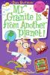
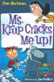
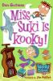
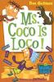
Gutman: My Weird School school, humor
A fun series of books about school life that appeal to reluctant readers.
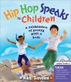
Hip Hop Speaks to Children: A Celebration of Poetry with a Beat c2008 poetry
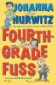
Hurwitz: Fourth Grade Fuss c2004 school story
Julio and his friends enjoy their fourth grade activities - the yard sale, ice skating, and a surprise party; but the students get serious when they have to study for end-of-the-year statewide tests.
Kehret: Shelter Dogs: Amazing Stories of Adopted Strays c1999 animals, non-fiction
Tells the story of 8 dogs who were saved from the animal shelter and went on to better lives.

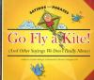
Klingel: Go Fly a Kite! (And Other Sayings We Don't Really Mean) c2008 idioms, figures of speech
Explains the meaning of many common idiomatic expressions used in English.
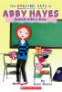
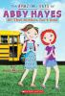
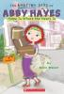
Mazer: Amazing Days of Abby Hayes fiction
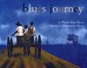
Myers: Blues Journey c2003 poetry, ethnic diversity
Presents blues lyrics that chronicle the history of the African-American experience, and includes information about the development of blues music.
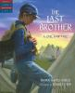
Noble: The Last Brother (Tales of Young America series) c2006 historical fiction
Gabe becomes a bugler in the Civil War to protect his only surviving brother.
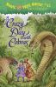
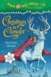
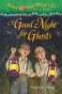
Osborne: Magic Tree House series time travel, fiction
Explore the world with Jack and Annie.

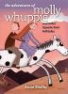
Shelby: Adventures of Molly Whuppie and Other Appalachian Folktales c2007
A collection of fourteen that combine traditional Appalachian folktales with contemporary themes.
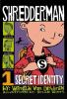
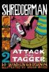
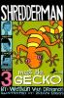
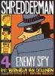
Van Draanen: Shredderman series fiction
Discover how Nolan Byrd goes from being the number one nerd at Cedar Valley Elementary to a world famous superhero.

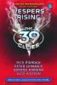
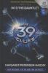
Various authors: 39 Clues series mystery
Follow Amy Cahill and her brother, Dan, as they travel the world to hunt for the 39 Clues.

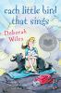
Wiles: Each Little Bird Sings c2005 family life, grief, fiction
Comfort Snowberger is well acquainted with death since her family runs the funeral parlor in their small southern town, but even so the ten-year-old is unprepared for the series of heart-wrenching events that begins on the first day of Easter vacation with the sudden death of her beloved great-uncle Edisto.

