A few good Books – Pre School – Kindergarten
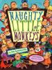
Aylesworth: Naughty Little Monkeys c2003 alphabet
Twenty-six monkeys get into mischief when their parents go out for the evening in this rhyming alphabet book.
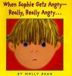
Bang: When Sophie Gets Angry - Really, Really Angry... c1999 character
Sophie expresses her anger when she must surrender a toy to her sister.
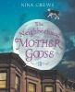
Crews: The Neighborhood Mother Goose c2004 nursery rhymes, diversity
This collection of nursery rhymes features the familiar and unfamiliar, all set in the city.
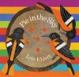
Ehlert: Pie in the Sky c2004 family fiction
As a father and his child view the cherry tree in their back yard, they refer to it as a pie tree. Includes a recipe.
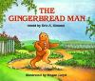
Kimmel: The Gingerbread Man c1993 fairy tale
This familiar fairy tale features a gingerbread man who runs away from the woman who bakes him and meets other animals along the way, including a clever fox.
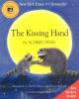
Penn:The Kissing Hand c1993 family life
Chester Raccoon is afraid to attend kindergarten until his mother shows him a special way to take her love along.
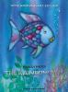
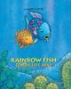
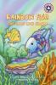
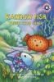
Pfister: Rainbow Fish animal stories
The most beautiful fish in the ocean with the shimmering silver scales discovers the beauty of sharing.
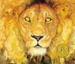
Pinkney: The Lion & the Mouse c2009 wordless, fairy tale
Wordless retelling of an Aesop fable, an adventuresome mouse proves that even small creatures are capable of great deeds when he rescues the King of the Jungle.
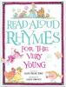
Prelutsky: Read-Aloud Rhymes for the Very Young c1986 poetry
This collection of 200 short poems is designed for young children and includes illustrations that correlate with the poems.
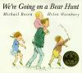
Rosen: We're Going on a Bear Hunt c2003 animals, fiction
Brave bear hunters go through grass, a river, mud and other obstacles before the inevitable encounter with the bear forces a headlong retreat.

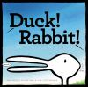
Rosenthal: Duck! Rabbit! c2009 animals
Two unseen characters argue about whether the creature they are looking at is a rabbit or a duck.
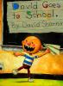
Shannon: David Goes to School c1999 humor
David's school behavior needs to be improved.
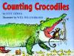
Sierra: Counting Crocodiles c1997 counting, rhyming
A monkey outsmarts ten crocodiles that stand between her and a banana tree by using her ability to count.
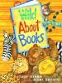
Sierra: Wild About Books c2004 animals, humor
A librarian accidentally drives her bookmobile to the zoo and subsequently reads a Dr. Seuss book to the animals.
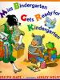
Slate: Miss Bindergarten Gets Ready for Kindergarten c2003 school
Introduces the letters of the alphabet as Miss Bindergarten and her students get ready for kindergarten.

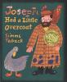

Taback: Joseph had a Little Overcoat c1999 diversity
Joseph starts out with an overcoat and ends with a button.

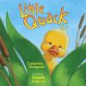
Thompson: Little Quack c2003 animals
Mama Duck encourages her four ducklings to leave the nest. The youngest and smallest, Little Quack, proves to be the most reluctant.
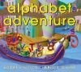
Wood: Alphabet Adventure c2001 alphabet
The letters of the alphabet join the search to help "i" find her dot in order to continue their journey in this colorful alphabet book.
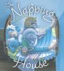
Wood:The Napping House c1984 sleep, fiction
While a number of creatures sleep, a flea causes a commotion among them with just one bite.

